**User Details – Spring**

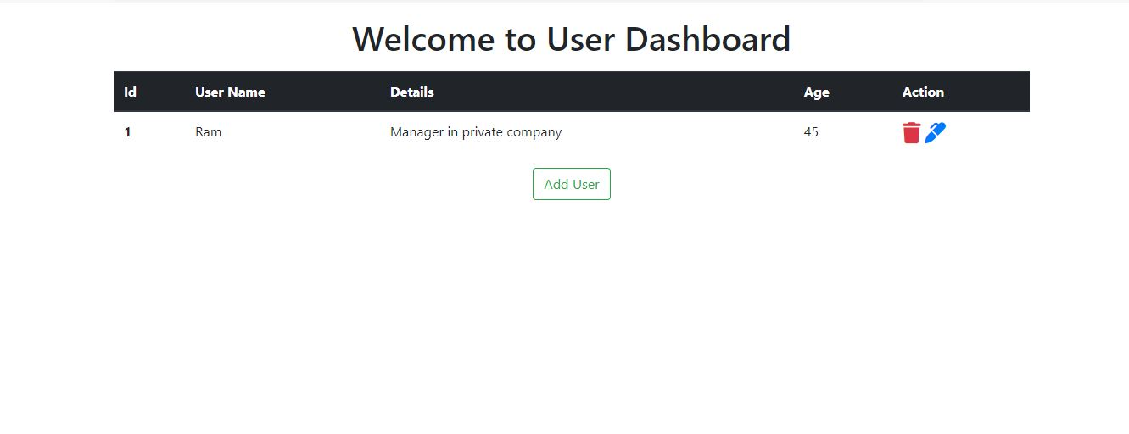

**User Dashboard where added user details and to add new user details will be available**

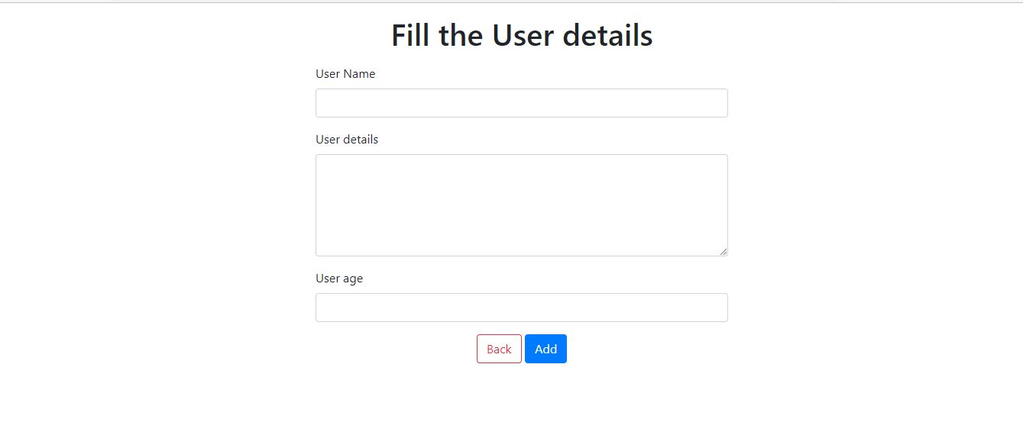

**Page to fill user details. Fields for user details are user name, user details, and user age.**

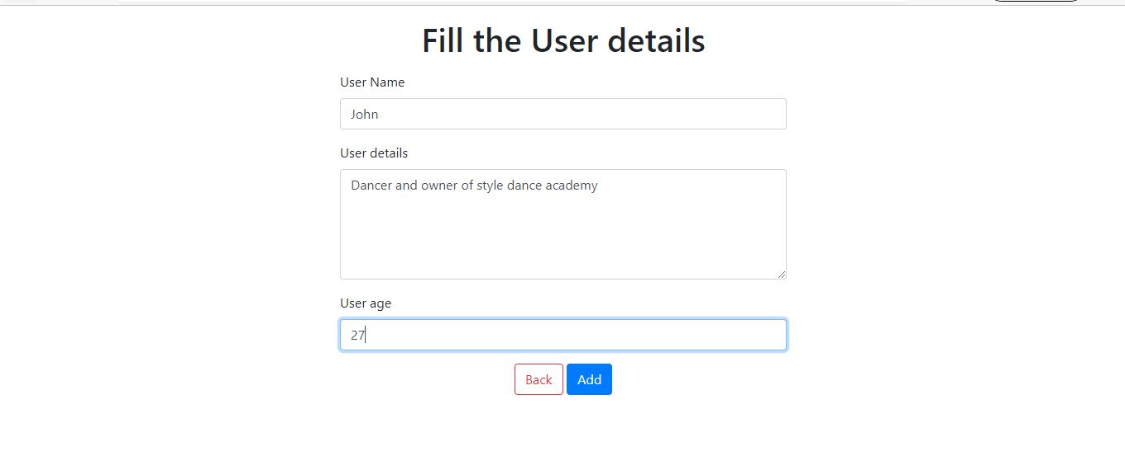

**Details are typed in the fields and click on add button**

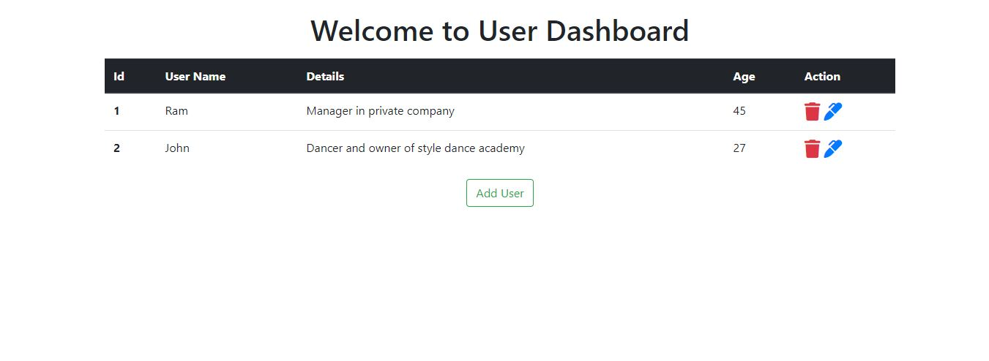

**Details are successfully added and displayed in the list.**

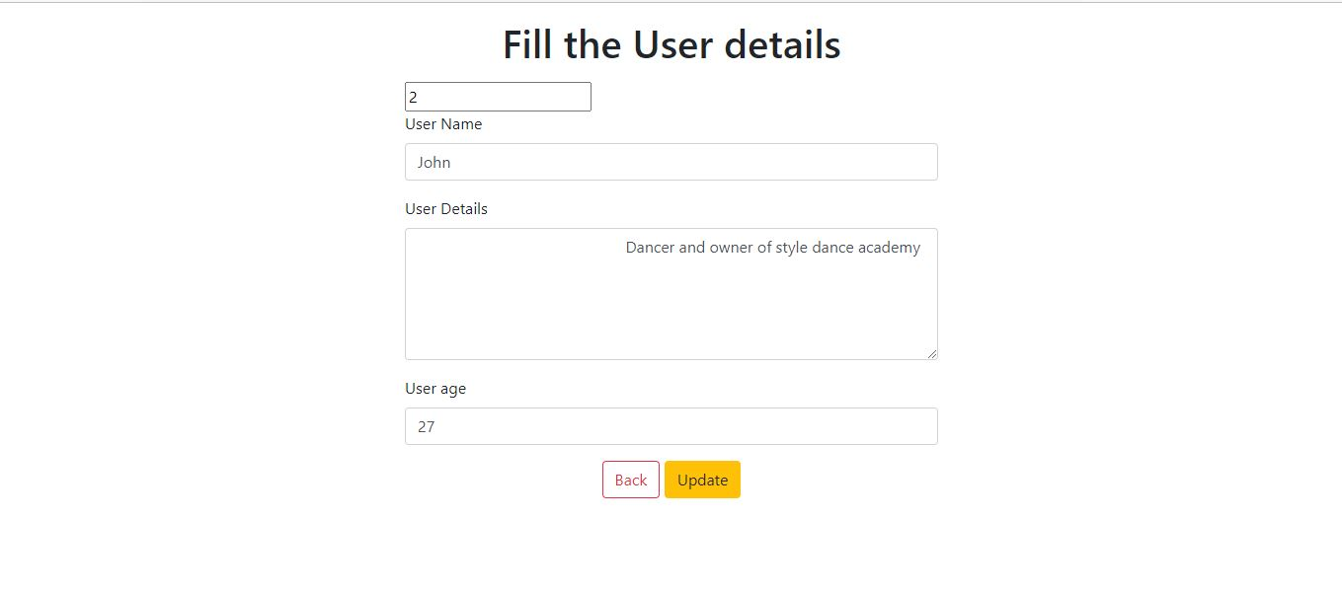

**Details can be modified once added and then click on the update button**

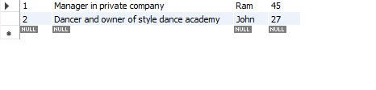

**Mysql table where data added is reflected.**